**Diagrams**

1. Data Flow Diagrams (Level 0 and Level 1)

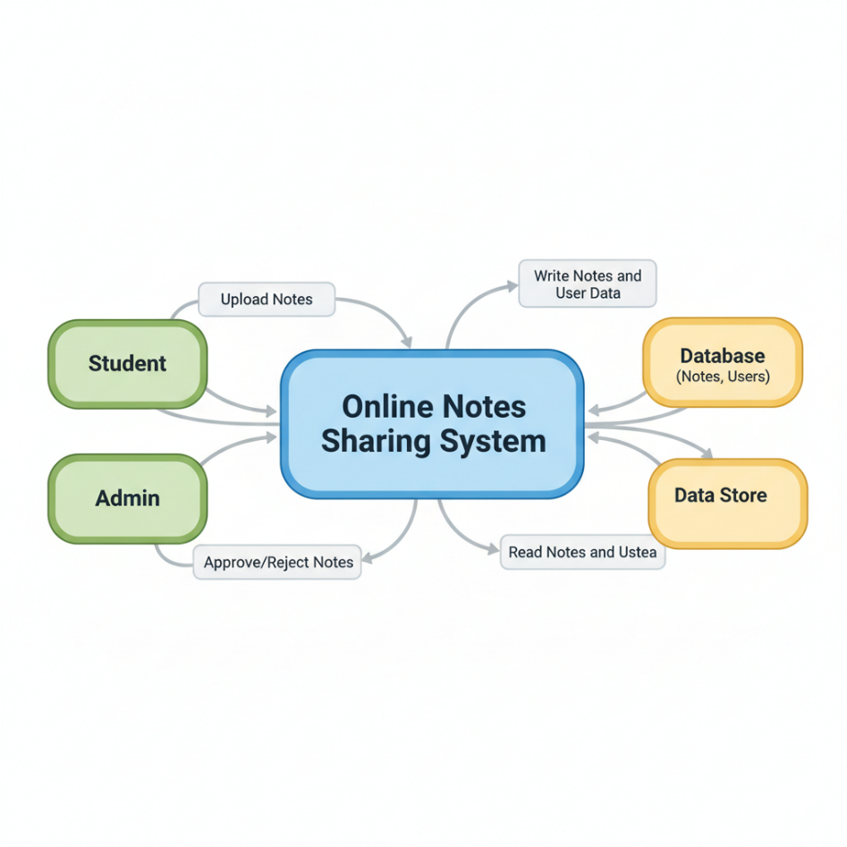

**2.Level 1 Data Flow Diagram**

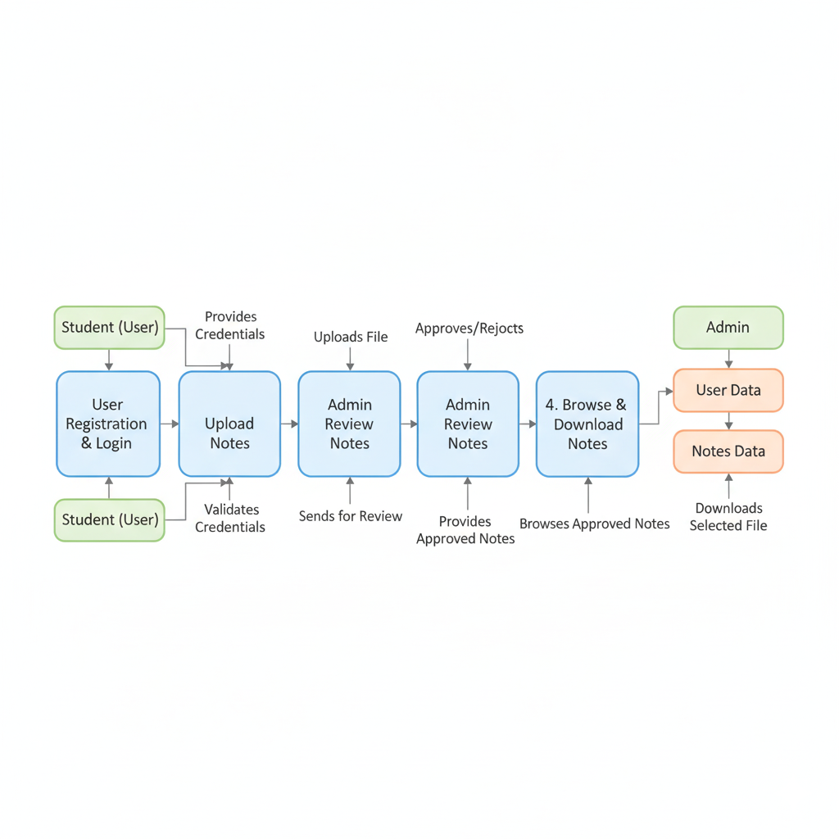

**3. System Architecture**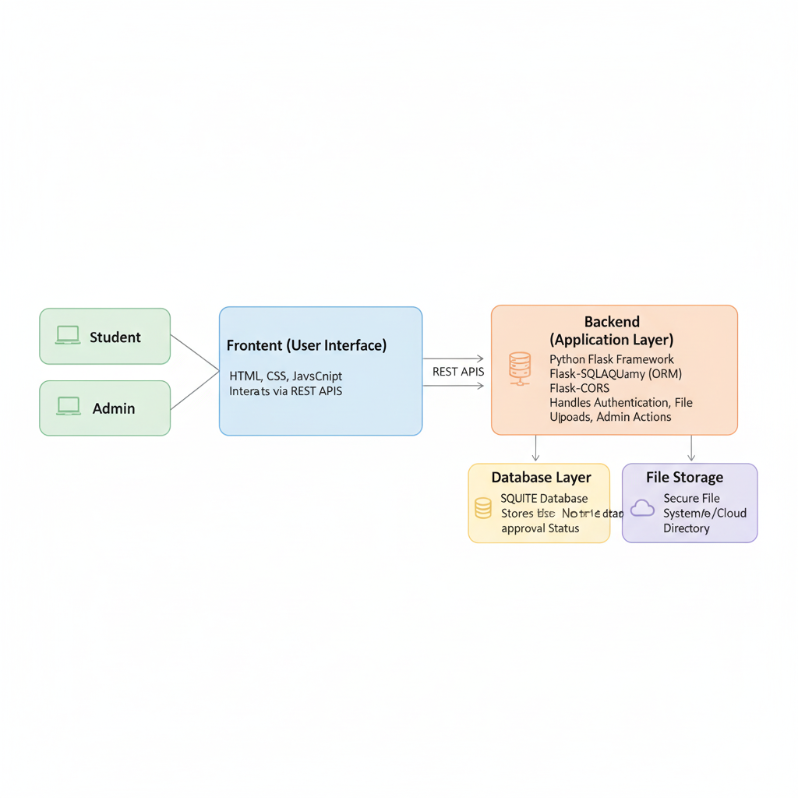

**4, Use Case Diagram**

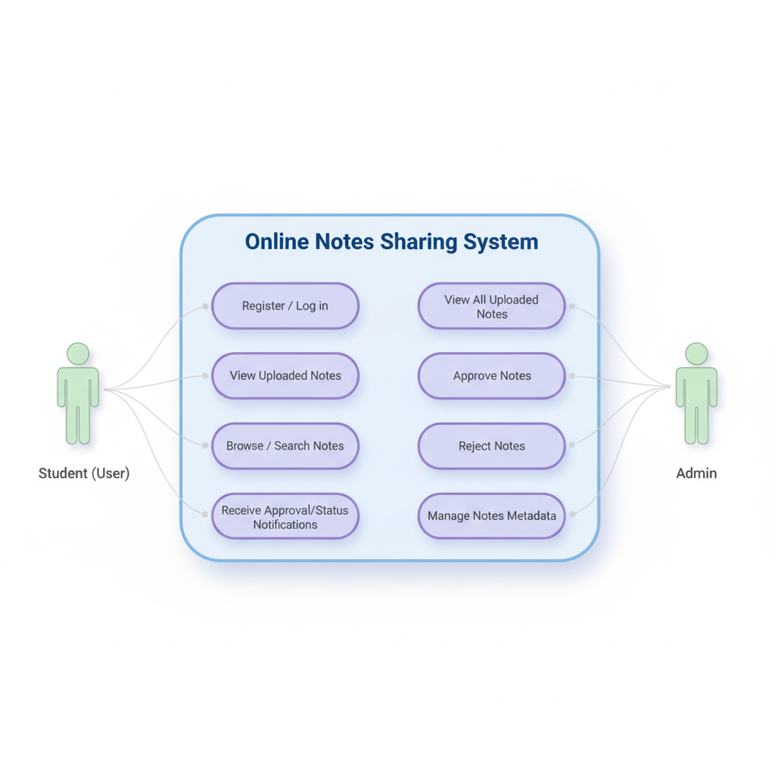

**5. UML Class Diagram**

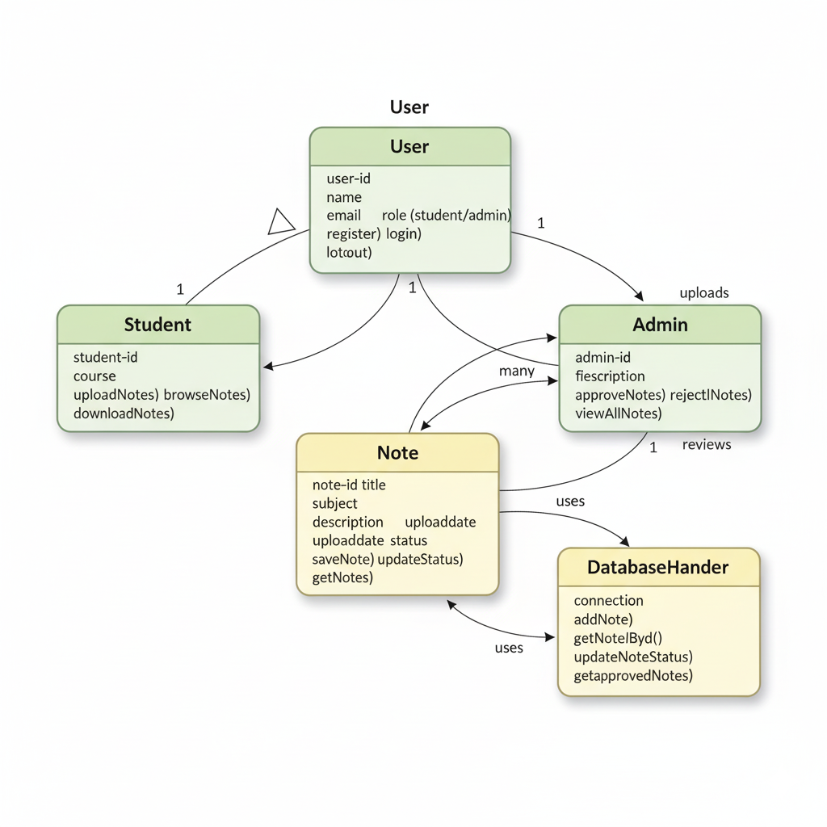

**6. E-R Diagram**

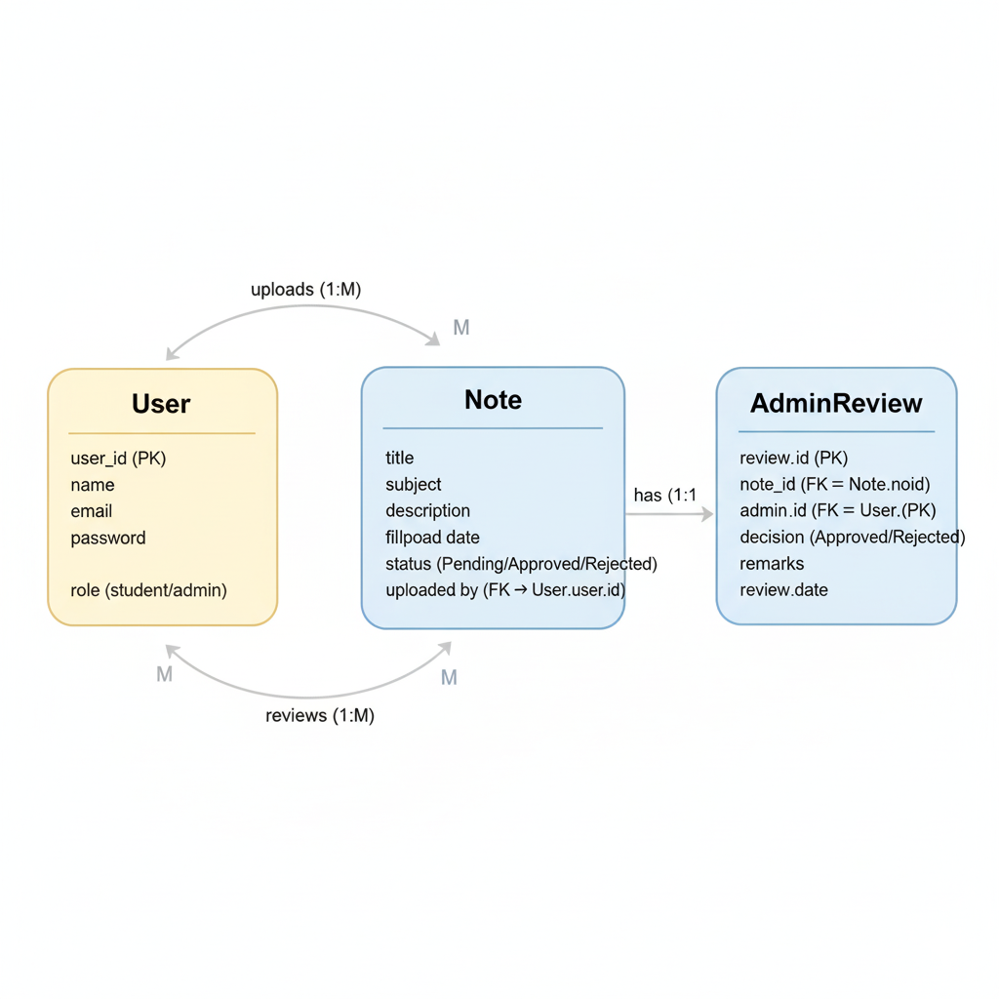

**7. Schema Diagram**

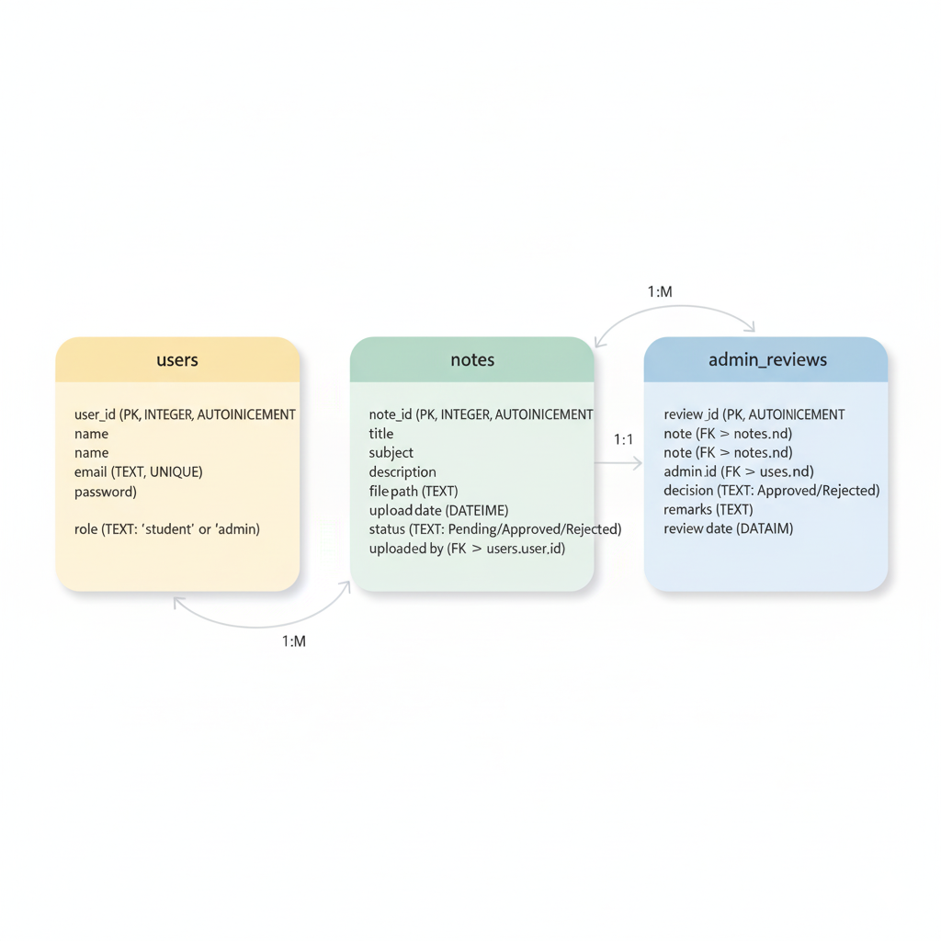

**8. State Machine Diagram**

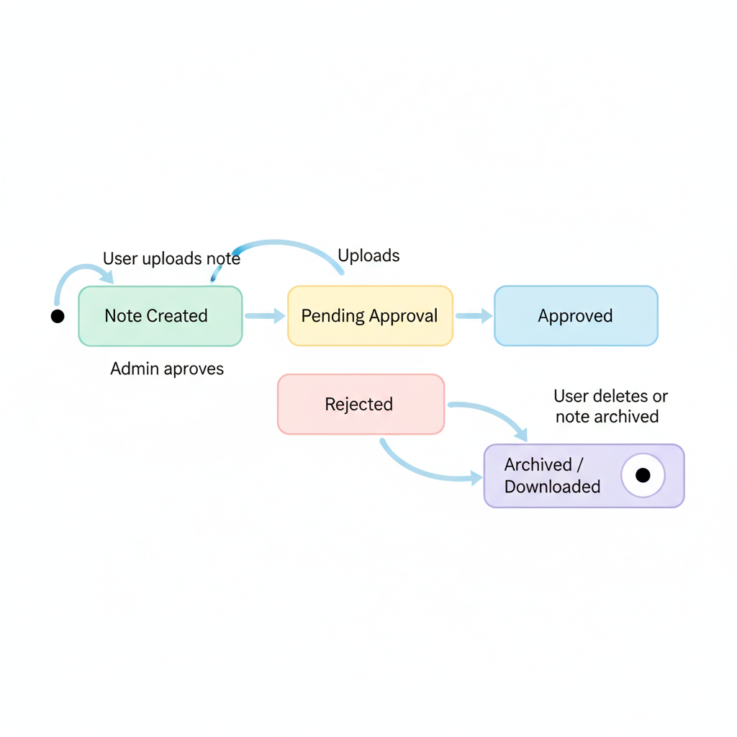

**9. Activity Diagram**

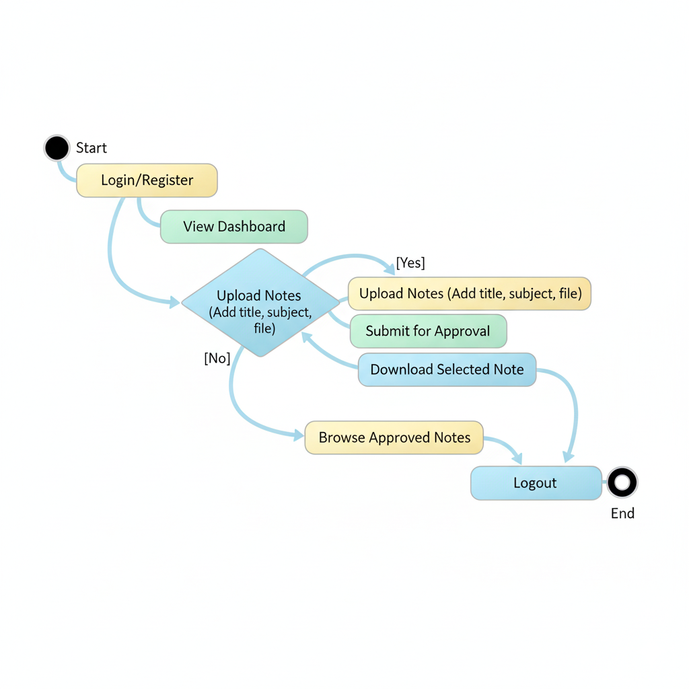

**10. System Flow Chart**

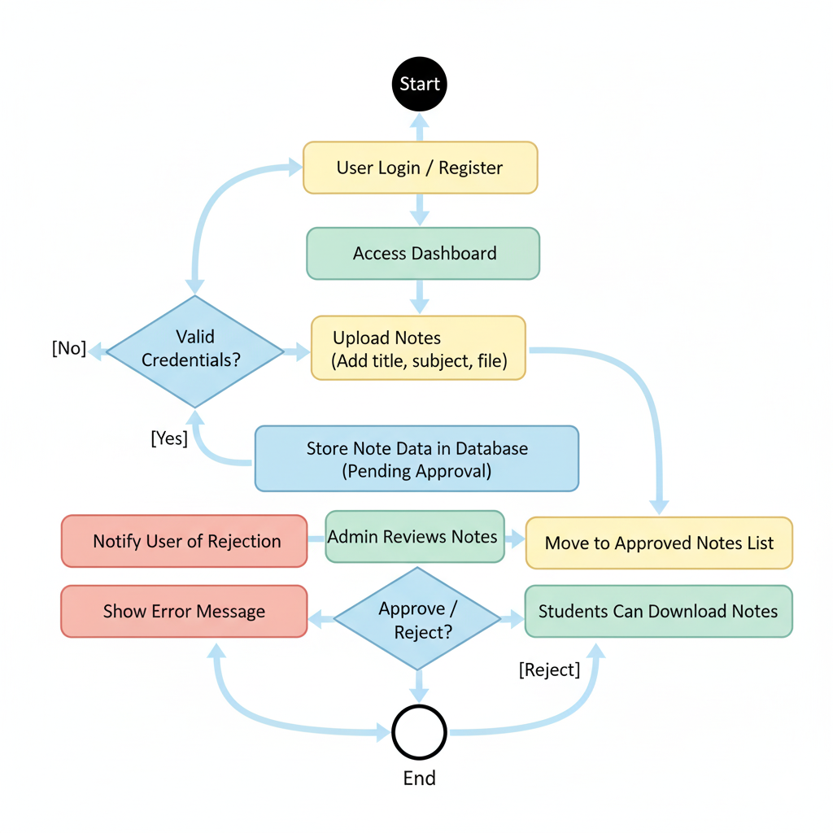

**11. Test Case Design Diagram**

